**User Requirements Specification for the GreenSpace App**

**Project title:** GW4+ Fresh: GreenSpace Application

**Acronym:** GSA

**Authors:** Victoria Hussey1, Rory Burford1

**Contributors:** Fiona Joyce2, Annalise Hooper2, Toby Champneys1, Jack Greenhalgh1, Franciszek Bydalek3, Luke Lear4, Joshua Rainbow3, Elliot Druce1

*1 University of Bristol, 2 Cardiff University, 3 University of Bath, 4 University of Exeter*

**Change History**

|  |  |  |  |
| --- | --- | --- | --- |
| **Date** | **Version** | **Description** | **Updated by** |
| 01/07/2020 | 0.1 | Initial draft | RB, VH |

**Table of Contents**

1. Context 2

1.1 – Overview of the current situation 2

1.2 – Summary of analyses 3

1.2.1 – Recorded COVID-19 cases vs green space in UK metropolitan boroughs 3

1.2.2 – Recorded COVID-19 cases vs green space in London boroughs 3

1.2.3 – Issued fines vs access to nature in London BCUs 3

1.3 – Our solution 4

2. System purpose 6

2.1 – Overview 6

2.2 – Beneficiaries 6

2.3 – Location 6

2.4 – Responsibilities 7

3. System Requirements 7

3.1 – Databases 7

3.1.1 – Green space Raster (GSR) 7

3.1.2 – User data 8

3.1.3 – Weather data 8

3.2 - Systems 8

3.2.1 – User Interface (UI) 8

3.2.2 – Distance calculator 8

3.2.3 – Usage algorithm 8

3.3 – Example function flow chart 8

3.3.1 – User enters their postcode and a specified date/time 8

Reference locations 10

4.1 – Repository 10

4.2 – Reference list 10

# Context

## 1.1 – Overview of the current situation

National responses to the COVID-19 pandemic have recently tested the provision of parks, gardens and other green space at an unprecedented level. Previous research has shown that access to urban green space plays a noticeable role in improving individuals’ mental health and wellbeing [1-2]. Indeed, urban green space provide locations for a wide range of healthy activities, including:

* Socialisation
* Sport and leisure
* Dog-walking
* Outdoor activities or sport for children/dependents
* Pleasure reading and outdoor relaxation

In spite of the documented benefits, there have been concerns surrounding overcrowding in urbanised public green space during 2020 COVID-19 lockdowns. 22% of Fixed Penalty Notices (FPN)s in England were given out due to breaches of social distancing in public spaces – second only to fines for non-essential long-distance travel [3]. Furthermore, media outlets have frequently published stories concerning the misuse of green space. For instance, on 4th April 2020, The Sun newspaper published the headline ‘*COVIDIOTS London park forced to close after 3,000 ignore coronavirus lockdown and cops break up 18th birthday party’*, whilst the Daily Express reported that Londoners were “flocking to parks despite coronavirus threat” as early as 23rd March. Alarmist reporting such as this can increase anxiety about spending time in public parks and gardens and can lead to the abuse or shaming of those who continue to go. This directly undermines official advice for people suffering from anxiety to take regular exercise in local green space [4]. As part of the 3rd NERC Digital Sprint Hackathon, we analysed data concerning the availability of green space and COVID-19 transmission rates in order to assess whether or not public green spaces are significant transmission sites for COVID-19.

## 1.2 – Summary of analyses

### 1.2.1 – Recorded COVID-19 cases vs green space in UK metropolitan boroughs

Across UK metropolitan boroughs, there was an inverse relationship between green space area (as a proportion of total urban area) and the number of recorded COVID-19 cases (Figure 1b). This indicates that, on a nationwide level, green spaces do not appear to be significant sites for the transmission of COVID-19. Given the established health benefits of green spaces, more work should therefore be done to counteract negative perceptions of green space in the media.

### 1.2.2 – Recorded COVID-19 cases vs green space in London boroughs

A focused analysis of London boroughs bucked the nationwide trend, instead revealing a weak positive relationship (Figure 1a). Relative green space area in London is extremely low (Figure 1b). Moreover, the Greater London Built-Up Area is by far the most densely populated urban area in the UK, with more than 5600 residents per square kilometre [5]. This means that green space per capita is especially low in the UK capital, so public parks and gardens have been overwhelmed by recent lockdown restrictions. As a result, better management of London green spaces may be necessary in order to limit the transmission of COVID-19.

### 1.2.3 – Issued fines vs access to nature in London BCUs

A further analysis in London BCUs compared the number of households with “good access to nature” [6] with the issuance of FPNs [7]. A weak negative correlation was found (Figure 2), which may indicate that people with greater access to green spaces are less likely to contravene lockdown restrictions. This would correspond with prior research findings that (1) urban green space has positive impacts on mental health [8], and (2) adherence to social distancing restrictions is less likely in individuals displaying heightened levels of anxiety and depression [9].

## 1.3 – Our solution

In light of the valuable role that urban green spaces play in mental health and the negative portrayals that can be found in press/social media, we propose the development of a smartphone application to help socially-distancing individuals find public parks and decide when to visit. The application will utilise GIS data to locate the nearest green spaces, which will be filterable by desirable factors (such as park size, and the provision of paths). A dynamic estimation of peak and low usage times will be developed with machine learning techniques entrained by weather patterns, local green space per capita ratios, usage statistics and user-reported data. Forecasts of usage and weather will allow the user to make an informed decision on when to visit. This short-term digital solution will combat the overcrowding of urban green spaces (as observed in London), as well as the negative perceptions of green space usage in national media.

We also recommend additional data collection using footfall sensors placed at the access points to major green spaces; this would both improve application functionality and would generate a useful novel database for policymakers.

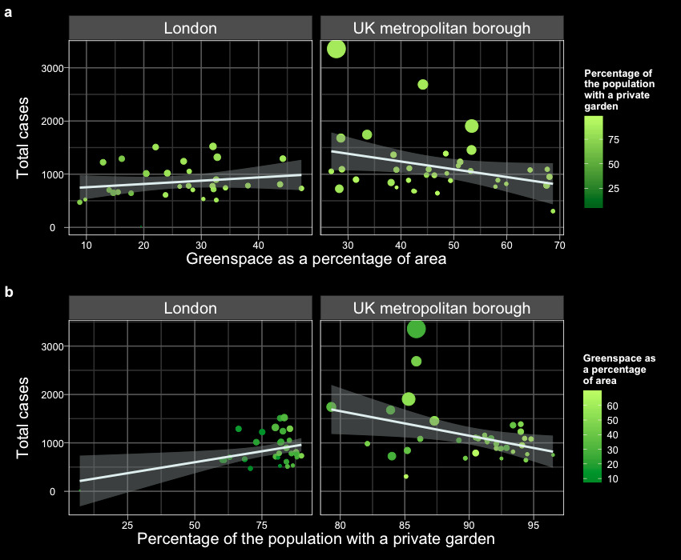

**Fig. 1a**

**Fig. 1b**

London

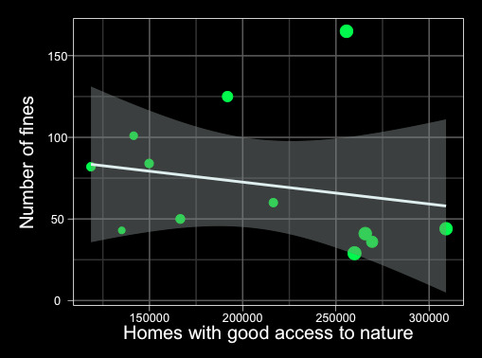

**Fig. 2**

Results of analyses conducted as part of the NERC Digital Sprint Hackathon 3: Ecosystem Services.

Figure 1a: COVID-19 cases versus percentage greenspace area in London boroughs.

Figure 1b: COVID-19 cases versus percentage greenspace area in UK metropoliton boroughs.

Figure 2: FPNs for breaking lockdown restrictions versus homes with good access to nature for London BCUs.

# System purpose

## 2.1 – Overview

In this document, we describe the user requirements of such an application, hereafter referred to as the green space app (GSA). GSA is proposed as an interactive reference mobile application, which urban-situated users can consult to assess how busy their local green space is. The development of this application will revolve around:

1. A GIS database of green space locations, termed the green space raster (GSR);
2. Open weather service data (WSD);
3. A dynamic algorithm that estimates the degree of usage at any given time, referred to as the usage algorithm (UA).

GSA is being proposed as part of the NERC COVID-19 Digital Sprint Hackathon 3: Ecosystem Services. This is an open call for environmental, health and social science researchers to suggest digital solutions (relating to ecosystem services) that could help to improve health outcomes in the UK. Our analyses (available at <https://github.com/VictoriaHussey/FreshAndFurious_NERCHackathon3_GreenCities>) and previous studies suggest that access to green spaces is an important factor for maintaining mental health during periods of local or national lockdown and is correlated with improved adherence to lockdown measures. The obvious long-term solution to this problem would be to design towns and cities with greater access to green space. However, due to the acute nature of pandemics, an intelligent mobile application may prove a useful digital solution for maximising the use of pre-existing urban green spaces. GSR would promote access to urban green space during lockdown scenarios, whilst reassuring users that their personal wellbeing will not be compromised through overcrowding.

## 2.2 – Beneficiaries

Parties who will primarily benefit from the GSA include:

* Citizens – the target users of the application. Citizens will be able to locate nearby green spaces and access weather and crowding data to help them decide when and where to visit.
* The National Health Service (NHS), which treats Citizens suffering from the direct and indirect effects of the ongoing pandemic. These include sufferers of: COVID-19, anxiety, depression, and orthopaedic and dermatological issues resulting from sedentary lifestyles.
* Law Enforcement Agencies, which have been tasked with the difficult job of enforcing lockdown infractions.
* Local and National Governing Bodies, which will gain access to novel data generated by the UA. Governing bodies will also benefit indirectly from reduced strain on the NHS and improved adherence to lockdown measures, which should increase the speed of national recovery.

## 2.3 – Location

The GSA will be available to any potential user via the Internet, such as users on the Google Play Store. However, the GSR will only include UK data. The application will operate in urban settings only, where public green space is understood to be under greater pressure of overcrowding compared to rural settings. Initially, the application will be operational in London, followed by other large urban settings.

## 2.4 – Responsibilities

The responsibilities of the GSA will primarily be:

* To take inputs of postcode data and return the location and distance of the nearest urban green spaces.
* To provide users to see weather forecasts for a given urban green space.
* A simple review system, where users can rate how suitable a given green space was to their activity and how busy it was at the time of use.
* To apply machine learning techniques to location, weather and review data in order to create a dynamic UA for the forecasting of future usage.

Other desirable features of the GSA are:

* To categorise urban green spaces by additional fields such as size, popularity, density of paths, and flowerbeds. These fields will be divided into discrete, qualitative categories (e.g. “large” rather than “166 ha”) for ease of understanding.
* To include filters for additional fields when searching for nearby urban green spaces. Such filters will help users to choose a green space appropriate for their activity of choice (e.g. running, bird watching).
* To allow users to create calendar events (compatible with major calendar providers) with reminders of when they wish to visit an urban green space.
* To allow users to input preferred weather for specific activities: for instance, a user may prefer to run in weather that is overcast, with temperatures between 15°C and 20°C, < 5% likelihood of precipitation and low winds.
* A search feature that combines weather preferences, weather forecasts and the usage forecasts to suggest times when conditions will be optimum for a given activity. This would connect to the calendar event feature.
* To integrate footfall data at access points to urban green spaces (recommended to NERC in our Hackathon entry) into the UA.

# System Requirements

## 3.1 – Databases

### 3.1.1 – Green space Raster (GSR)

GIS data will be used to provide the crucial spatial aspect to this mobile application. The GSR will contain:

* Coordinates of green space access points;
* Conversion tables from postcodes to coordinates;
* Green space area per capita (from local population) for each green space.

Upon input of a postcode, straight-line calculations will be used to find the closest ten access points in the database. If Internet connection is available, Google Maps data will be integrated in order to include estimated walking times to each access point.

### 3.1.2 – User data

Central servers will store:

* Bottom-data generated from voluntary user ratings of present green space crowding and green space suitability for activity;
* User search data;
* Temporal user location and activity data (provided voluntarily along with ratings).

These data will be used to train the UA and may be used in other features such as suitability scores for different activities and green spaces.

### 3.1.3 – Weather data

Localised weather data and forecasting originating from open top-down data sources such as the UK Met Office. Weather data will be stored as an additional field alongside usage data and will be used to train the UA.

## 3.2 - Systems

### 3.2.1 – User Interface (UI)

The UI must be clean, and easy to access. The proposed structure is based on tabs:

* Home tab – postcode entry field, time/date entry field and search button. Later versions may include a filter for qualitative values in fields such as *size*, *runnability* and *flowerbed density*.
* Results tab – short list of green space results, pinned on a map sourced from Open Street Map and colour-coded by forecast number of users. Clicking on a pin should bring up estimated walking times and a link to the Google Maps route planner. Later versions may include a star rating for
* Weather tab – forecasts for the most recent green space selected on the results tab.

Future versions may include:

* Preferences tab, for storage of preferences such as desirable weather for a given activity.

### 3.2.2 – Distance calculator

This system must be capable of accessing raster data, converting postcodes into coordinates and calculating straight line distances. To decrease processing time, raster data will be stored with helpful fields including all postcodes within a 2 km radius; this avoids the need to iteratively calculate distances to every green space.

### 3.2.3 – Usage algorithm

An iterative machine learning algorithm that is trained by an initial period (alpha testing) of usage, temporal and weather data, using logistic regression to form basic relationships. This algorithm will be updated during a larger period of beta testing and will constantly update based upon centrally-stored databases after open release.

## 3.3 – Example function flow chart

### 3.3.1 – User enters their postcode and a specified date/time

* ‘Search’ button pressed
* GSR database accessed
* Scan through *NearbyPostcodes* field for access points to green spaces within 2 km of the postcode, adding them iteratively to a list *longlist_AccessPoints*
* Also retrieve corresponding coordinates for the postcode entered (alternatively, use location data from the mobile device), and store as *current_location*
* Iteratively run through all entries in this list:
  + Retrieve coordinates from the relevant fields
  + Subtract these from *current_location* to calculate a straight-line distance
  + If the straight-line distance is in the ten shortest found, then add to *shortlist_AccessPoints.*
* Access top-down intelligence (Google Maps / OpenStreetMap) to estimate walking times to each of these access points.
* Access top-down intelligence (Met Office, yr.no) and retrieve weather forecasts for the specified time at each of these access points.
* Iteratively run through *shortlist_AccessPoints* and input location data, weather forecasts and temporal data into the UA in order to generate a usage forecast for each of the points.
* Generate an OSM map of the relevant area, centred on *current_location*, with a default width of 2 km.
* Use the coordinates field from *shortlist_AccessPoints* to add pins to the map.
* Colour the pins according to the *UsageForecast* field.
* Generate pop-up bubbles for each pin, containing estimated walking times.
* Pass all visual/interactive data to the UI.

# Reference locations

## 4.1 – Repository

A full repository containing all data and code used for analyses referenced by this document can be found at:

<https://github.com/VictoriaHussey/FreshAndFurious_NERCHackathon3_GreenCities>.

## 4.2 – Reference list

[1] Liu H, Li F, Li J, Zhang Y. The relationships between urban parks, residents' physical activity, and mental health benefits: A case study from Beijing, China. Journal of environmental management. 2017 Apr 1;190:223-30.

[2] Wood L, Hooper P, Foster S, Bull F. Public greenspaces and positive mental health–investigating the relationship between access, quantity and types of parks and mental wellbeing. Health & place. 2017 Nov 1;48:63-71.

[3] National Police Chiefs Council [website]. Fixed Penalty Notice Pack, 2020. Available: [https://news.npcc.police.uk/ releases/statistical-update-on-number-of-lockdown-fines-given-by-police-1](https://news.npcc.police.uk/%20releases/statistical-update-on-number-of-lockdown-fines-given-by-police-1)

[4] UK Government [website]. Guidance for the public on the mental health and wellbeing aspects of coronavirus (COVID-19), 2020. Available: <https://www.gov.uk/government/publications/covid-19-guidance-for-the-public-on-mental-health-and-wellbeing/guidance-for-the-public-on-the-mental-health-and-wellbeing-aspects-of-coronavirus-covid-19> [Accessed 02/07/2020]

[5] London Datastore [website]. LSOA Atlas, 2011. Available: <https://data.london.gov.uk/dataset/c035528b-2c84-4509-8695-a212abc6ae37> [Accessed 01/07/2020]

[6] London Datastore [website]. Access Public Open Space Nature, 2014. Available: <https://data.london.gov.uk/dataset/access-public-open-space-and-nature-ward> [Accessed 01/07/2020].

[7] Metropolian Police [website]. Final FPN arrest analysis report, 2020. Available: [http://news.met.police.uk/documents/ final-fpn-arrest-analysis-report-96756](http://news.met.police.uk/documents/%20final-fpn-arrest-analysis-report-96756) [Accessed 01/07/2020]

[8] Nutsford D, Pearson AL, Kingham S. An ecological study investigating the association between access to urban greenspace and mental health. Public health. 2013 Nov 1;127(11):1005-11.

[9] Shevlin M, McBride O, Murphy J, Miller JG, Hartman TK, Levita L, Mason L, Martinez AP, McKay R, Stocks TV, Bennett KM. Anxiety, Depression, Traumatic Stress, and COVID-19 Related Anxiety in the UK General Population During the COVID-19 Pandemic.